Student Information System
UC-01 — Register for Course

Requirement · Use Case · Activity Diagram · Sequence Diagram · Communication Diagram

1. Requirement — BR-SIS-01
This requirement defines the core enrollment capability of the SIS. It is Priority 1 because no academic workflow can proceed without a student being able to register in a course. The requirement is fully traceable to Use Case UC-01, Activity Diagram AC-01, Sequence Diagram SC-01, and Communication Diagram CC-01.

Field | Detail
Req ID | BR-SIS-01
Priority | 1 — Must Have (core registration flow)
Module | Enrollment Management
Description | The system shall allow an authenticated Student to register for an available Course, subject to seat availability checks, and shall automatically create an Enrollment record (Status = "Active") and a confirmation Notification upon success.
Actor | Student (primary)
Pre-condition | Student is logged in. Course catalog for the semester is loaded. Student is not already enrolled in the selected course.
Post-condition | An Enrollment record exists (StudentID, CourseID, Status="Active"). A Notification record is created for the student. The student's schedule view is updated.
Source | Academic Registrar / Functional Requirements Specification v1.0
Date Reviewed | April 2025
Approved By | Academic Registrar Office

2. Use Case Table — UC-01
The use case below expands BR-SIS-01 into a structured, testable specification. It defines all actors, triggers, flows, and exceptions. The Main Flow maps step-by-step to the database operations shown in the sequence diagram (SC-01).

Field | Detail
Use Case ID | UC-01
Use Case Name | Register for Course
Requirement Ref | BR-SIS-01
Actor(s) | Student (primary) | System (secondary — creates records)
Trigger | Student selects a course from the catalog and clicks "Enroll".
Pre-conditions | 1. Student is authenticated via SSO.  2. Course catalog is populated for the current semester.  3. Student is NOT already enrolled in the selected course.
Post-conditions | 1. Enrollment record inserted: (StudentID, CourseID, EnrollmentDate, Status="Active").  2. Notification record inserted: (StudentID, NotificationText, NotificationDate).  3. Student schedule view reflects the new enrollment.
Main Flow | 1. Student opens the registration portal.  2. System verifies session token.  3. Student searches course catalog by semester/name.  4. System queries Course table and returns matching courses.  5. Student selects a CourseID and clicks "Enroll".  6. System checks: no duplicate Enrollment record exists.  7. System confirms seat availability from Course table.  8. System inserts Enrollment record (Status="Active").  9. System inserts Notification record for the student.  10. System displays: "Successfully enrolled in [CourseName]".
Alternative Flow | A1 — Already enrolled: Step 6 finds existing record → system returns "Already registered" error.  A2 — No seats: Step 7 returns 0 seats → display "Course full; add to waitlist?"  A3 — Session expired: Step 2 fails → redirect to login.
Exception Flow | E1 — Database error at Step 8: rollback, display "Enrollment failed — please retry".  E2 — Network timeout: display error, no record committed.
Includes | UC-16 (Authenticate / SSO Login)
Extended By | UC-11 (Drop Course) | UC-09 (View Schedule)
Priority | 1 — Must Have

3. Use Case Diagram — UCD-01 (UC-01 in context)
UC-01 (Register for Course) is shown in context with the other Student use cases. The diagram shows the <<include>> dependency on UC-16 (SSO Login) — every registration action requires prior authentication. The Registrar Admin can also manage enrollment caps (UC-10), and the System auto-computes notifications.

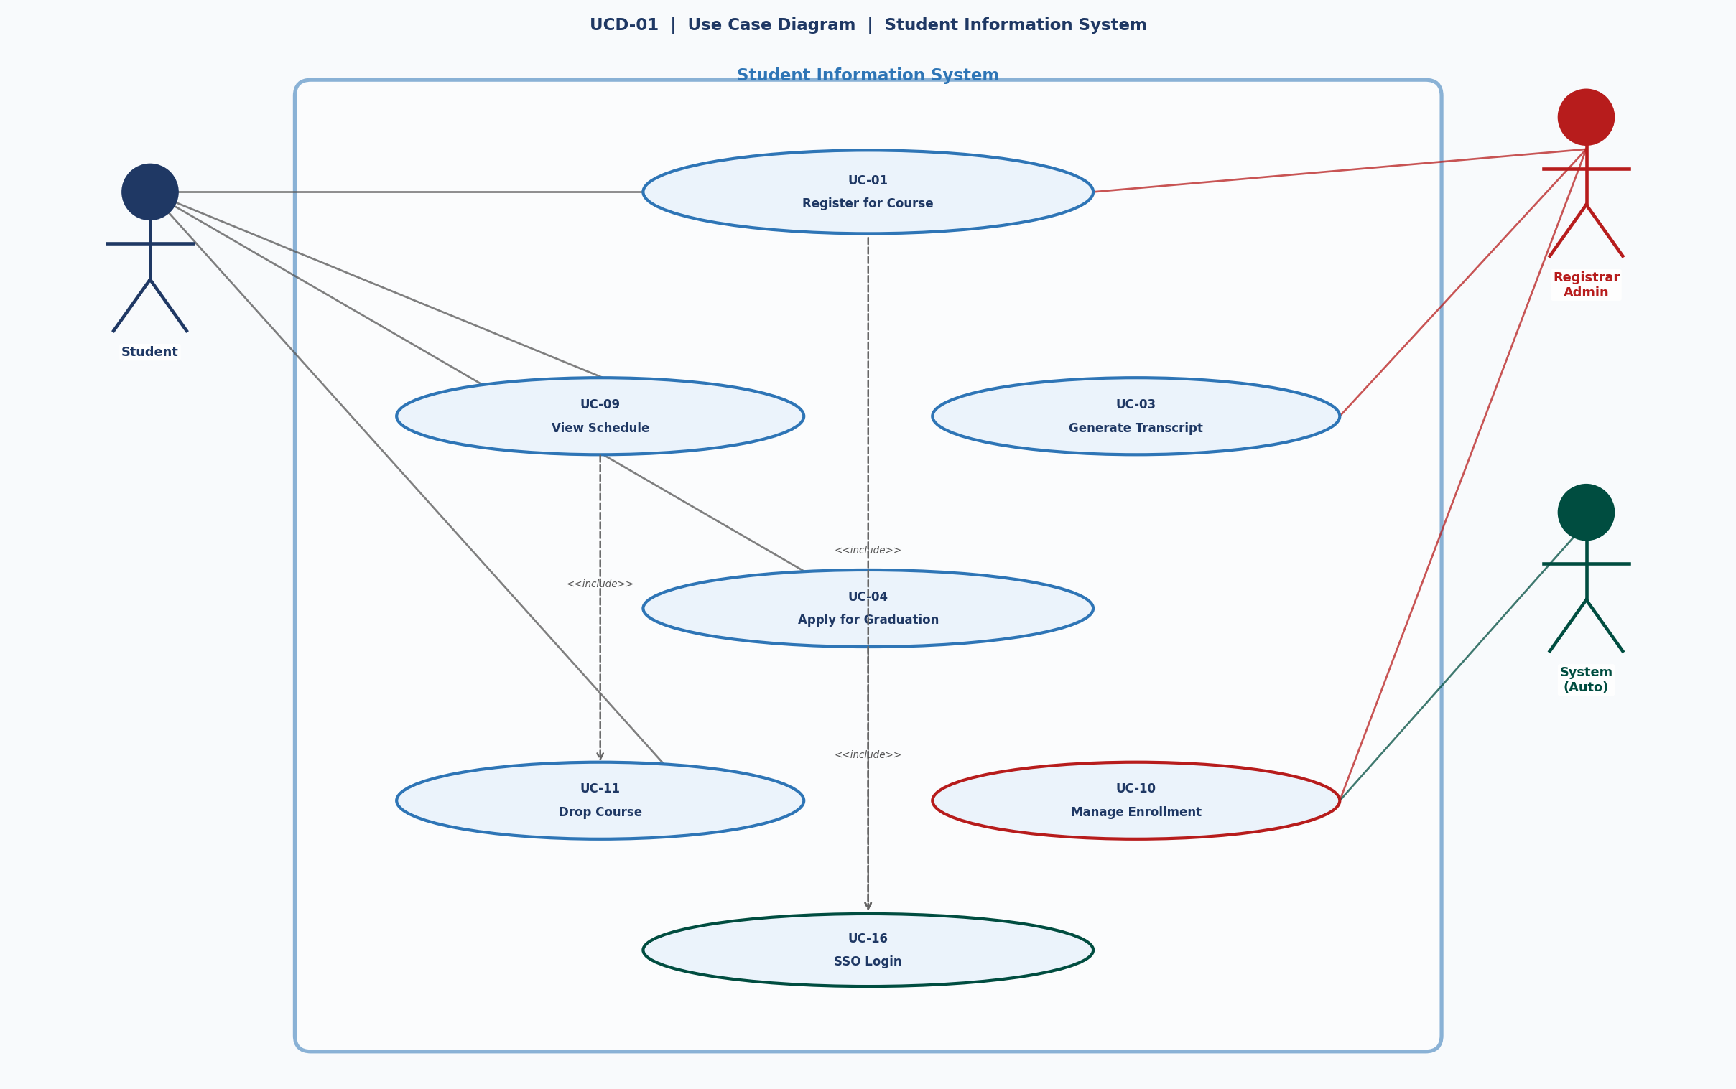
UCD-01 — Use Case Diagram (UC-01 highlighted in context)

4. Activity Diagram — AC-01
The activity diagram shows the complete flow for UC-01 including all decision points, alternate paths, and exception handling. Key decision gates are: (a) Is the course available? and (b) Are prerequisites met and seats available? Both lead to distinct YES/NO branches before the enrollment record is created.

ERD attributes exercised:
- Enrollment: EnrollmentID, StudentID (FK), CourseID (FK), EnrollmentDate, Status = "Active"
- Notification: StudentID (FK), NotificationText, NotificationDate
- Course: CourseID, CourseName, Credits, Semester (used in availability check)

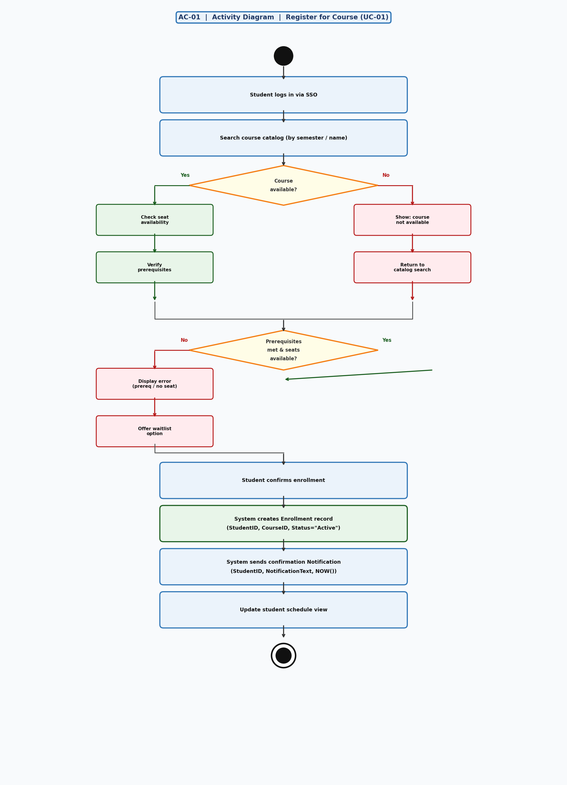
AC-01 — Activity Diagram — Register for Course (UC-01)

5. Sequence Diagram — SC-01
The sequence diagram shows the chronological message flow between 7 components. Each numbered message corresponds to an exact step in the UC-01 Main Flow. Database messages show the actual SQL column names from the ERD to make the data model explicit.

Component responsibilities:
- Auth Controller — validates session token against UserAccount table (UserID, Role)
- Enrollment Controller — orchestrates all business logic: duplicate check, seat check, record creation
- Course Table — source of CourseName, Credits, Semester, InstructorID (FK)
- Enrollment Table — receives INSERT (StudentID FK, CourseID FK, EnrollmentDate, Status)
- Notification Table — receives INSERT (StudentID FK, NotificationText, NotificationDate)

The [ALT] fragment at the end covers the "already enrolled" guard condition.

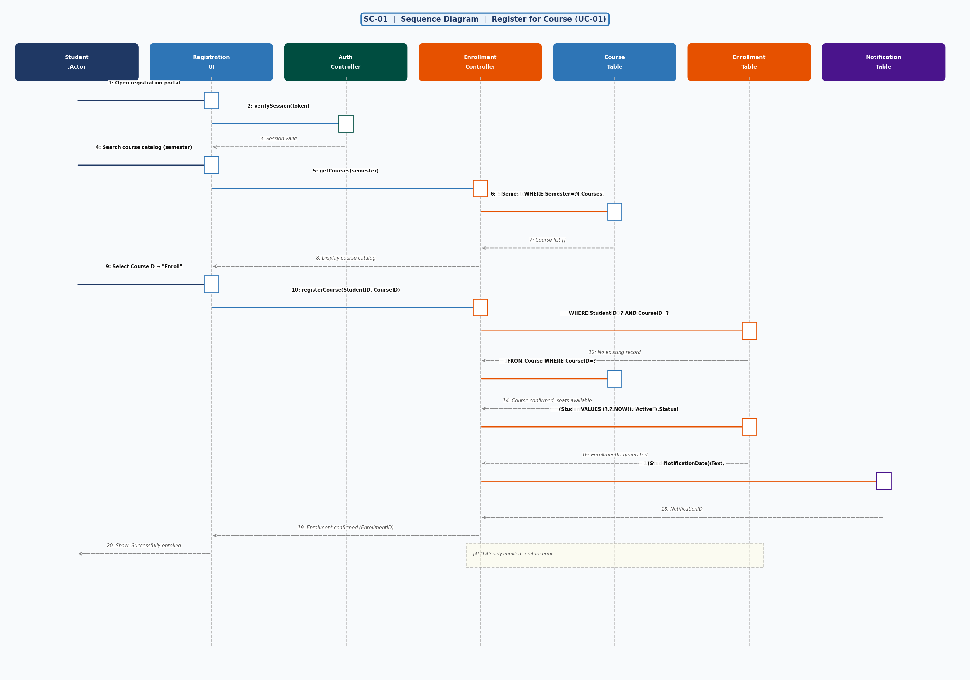
SC-01 — Sequence Diagram — Register for Course (UC-01)

6. Communication Diagram — CC-01
The communication diagram (derived from SC-01) re-presents the same interactions as structural object relationships rather than a timeline. Numbered messages (1–20) match exactly the sequence in SC-01. The diagram emphasises which objects collaborate directly and how many messages flow across each link.

Key object relationships visible in CC-01:
- Student ↔ RegistrationUI — 4 direct interactions (open, search, select, confirm)
- UI ↔ EnrollmentController — 2 requests (getCourses, registerCourse)
- EnrollmentController ↔ CourseTable — 2 SELECT queries (catalog + seat check)
- EnrollmentController ↔ EnrollmentTable — 1 SELECT (duplicate check) + 1 INSERT
- EnrollmentController ↔ NotificationTable — 1 INSERT (confirmation notification)
- UI ↔ AuthController — session verification (links to UC-16 <<include>>)

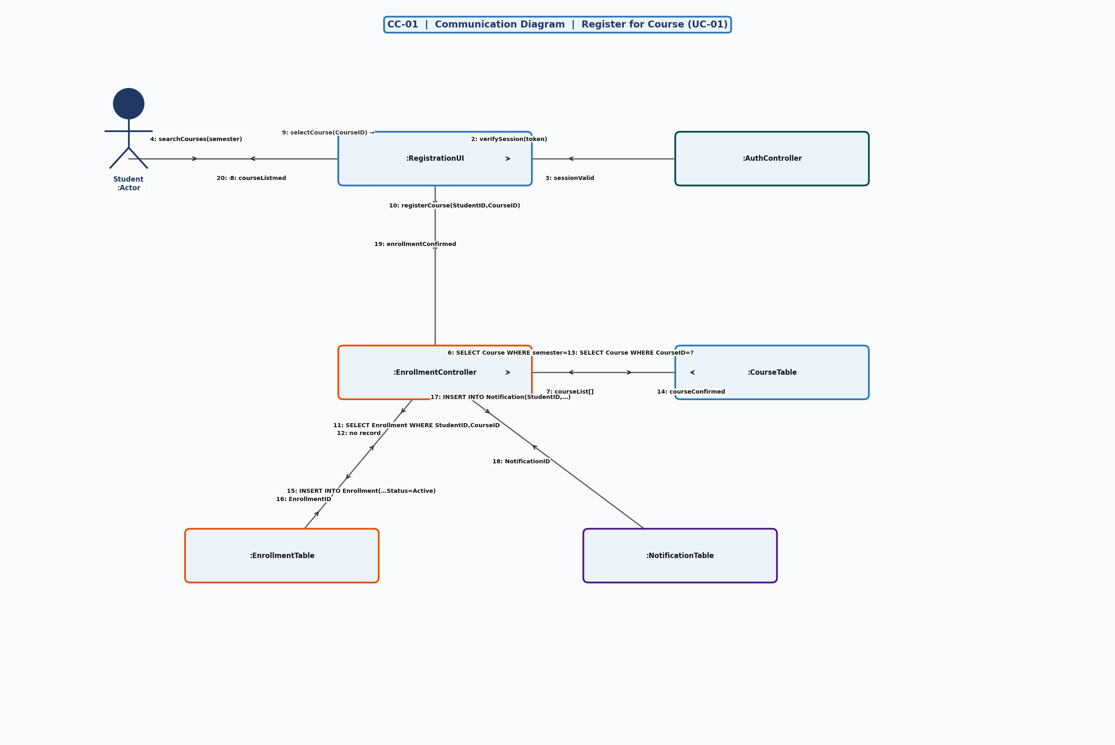
CC-01 — Communication Diagram — Register for Course (UC-01)

7. Traceability Summary
All artefacts in this handout are fully cross-referenced to the ERD and Requirements Specification.

Artefact | Maps To
BR-SIS-01 (Requirement) | Priority 1 · Functional Requirements Specification v1.0
UC-01 (Use Case Table) | BR-SIS-01 · Includes UC-16 · Extended by UC-09, UC-11
UCD-01 (Use Case Diagram) | UC-01 shown in system context with all 7 actors
AC-01 (Activity Diagram) | UC-01 main flow + 2 decision branches + exception paths
SC-01 (Sequence Diagram) | AC-01 steps 1–10 · ERD: Student, Enrollment, Course, Notification
CC-01 (Communication Diagram) | SC-01 messages 1–20 · same ERD entities as SC-01
ERD Entities Used | Student · Course · Enrollment · Notification · UserAccount
ERD Relationships Used | Student–RegistersIn→Enrollment · Enrollment–Includes→Course · Grade–Triggers→Notification

